Headteacher Update
Friday 15th March 2024
Dear Parents and Carers,
Can you believe we are heading into the last week of the spring term? This term seems to have flown by.
This week it has been lovely to welcome many of our year 3 parents who have joined their children for family lunch time. It was also great to catch up with lots of you during our parents’ evenings. Next week we are looking forward to our Easter assembly with Pastor Dave and Easter Bingo on Wednesday evening.

Dropping off at school
Please can we remind parents that children should be dropped at the gate in the morning so they can walk to their classrooms on their own - this really helps build children’s skills in independence.
Reception children are the only ones who should to be escorted to their classroom. Should you have any queries or messages then there are always members of staff at the gate for you to speak to, or alternatively messages can be passed on at the main office. Indeed, any messages regarding medication must be taken to the office so the correct paperwork can be completed.
Teachers are always busy settling children into their routines and activities at the start of the day, so it is a very difficult time for them to stop to talk to parents.
As part of transition, during the spring term we will begin to ask reception parents to leave their children at the gate in readiness for their move to Year 1.
Thank you for your support with this important part of our daily routine.

Age-appropriate gaming
We have been really shocked to find that children as young as our reception pupils are accessing games which have recommended ages of 13+ and above. Indeed, some of our youngest children are playing games with age ratings of 18. The games include Fortnite (age 13+), Call of Duty (age 18) and Grand Theft Auto (age 18). Young children in school have also spoken about the horror game series ‘Five Nights at Freddy’s (age 12+) and the film version of the game which is rated PG-13 due to its ‘strong violent content, bloody images and language’.
In school we are seeing the negative impact of exposure to such inappropriate, graphic material is having on children in their daily play, as they are choosing violent themes for their games such as killing one another with pretend/ imaginary knives. We have also seen an increase in children using inappropriate and aggressive language during their play.
We have contacted the SCiE team (Local Authority Safeguarding team) for advice on this matter as we believe this is a safeguarding concern.
Please support us by monitoring carefully the material children are able to access. Guidance for parents is offered on the following websites:
Online safety guide, tips and advice | Internet Matters
Keeping children safe online | NSPCC

New website
Our new school website has now been launched. This can be found by typing in the same address as before: Leftwich (leftwichprimary.co.uk) It looks fantastic, so please take a look if you have a moment. As always, any information you need about school can be found by accessing the website, including curriculum information, policies and important dates.

Attendance
During Wednesday’s assembly I talked to the children about attendance and shared with them some facts about time lost when they don’t attend school regularly. We talked about how some children find coming to school difficult and how we need to work together to make sure everyone feels happy and positive when they are here.
I shared the following graphic with the children which they found fascinating and surprising:

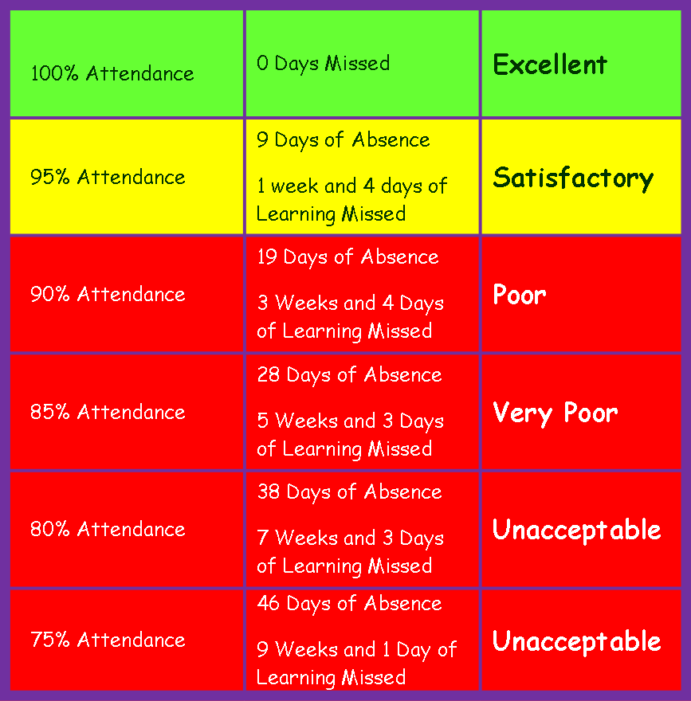

We do have some children whose attendance is already below 80% and, as you can see from the image, the number of days and weeks of lost learning that 75% attendance will equate to by the end of the year is 9 weeks and 1 day; this is over two months of learning time lost. I have challenged the children to help us get to 95% next term – I’ve promised them I’ll do a lap of school and a celebration dance if we make it!
Attendance at school is a national concern which the Government is trying to address. From next year fixed penalty notices issued to parents, by local authorities, for unauthorized absence will increase to £80 per parent.
As we enter the summer term, please work with us to improve attendance by ensuring children are in school as much as possible. We ask parents to try to arrange medical appointments for out of school hours, and consider carefully before booking holidays in term time because the impact of lost learning time for children is significant. The curriculum moves at a fast pace and it is very difficult to catch children up when they have missed days of learning.
Having said all that, It has been another great week for attendance so well done to all classes! Congratulations to Year 5 who are our attendance winners with 98%. We spun the wheel of fortune and they won a sweet treat which was given to them this afternoon.
Class attendance this week:
Reception : 95%
Year 1: 96%
Year 2: 96%
Year3: 96%
Year 4: 96%
Year 5: 98%
Year 6: 97%
Overall attendance for the school is 93.8% for the year to date – we’re almost at 94%!
Dates for your diaries:
Event | Date | Time | Classes involved
Easter Bingo | Wednesday 27th March | 5pm | All families
Non-Uniform – donation of £1 for FOLPS | Thursday 28th March | All day | All classes
Break up for spring break | Thursday 28th March | 3.15pm | All classes
Return to school | Monday 15th April | 8.30am | All classes
Bank Holiday – day off | Monday 6th May | All day | All classes
Year 6 SATS week | Mon 13th May – Fri 17th May | Every day | Year 6

Have a lovely weekend everyone.

Kind regards,
Mrs Harrison and Mrs Guy

