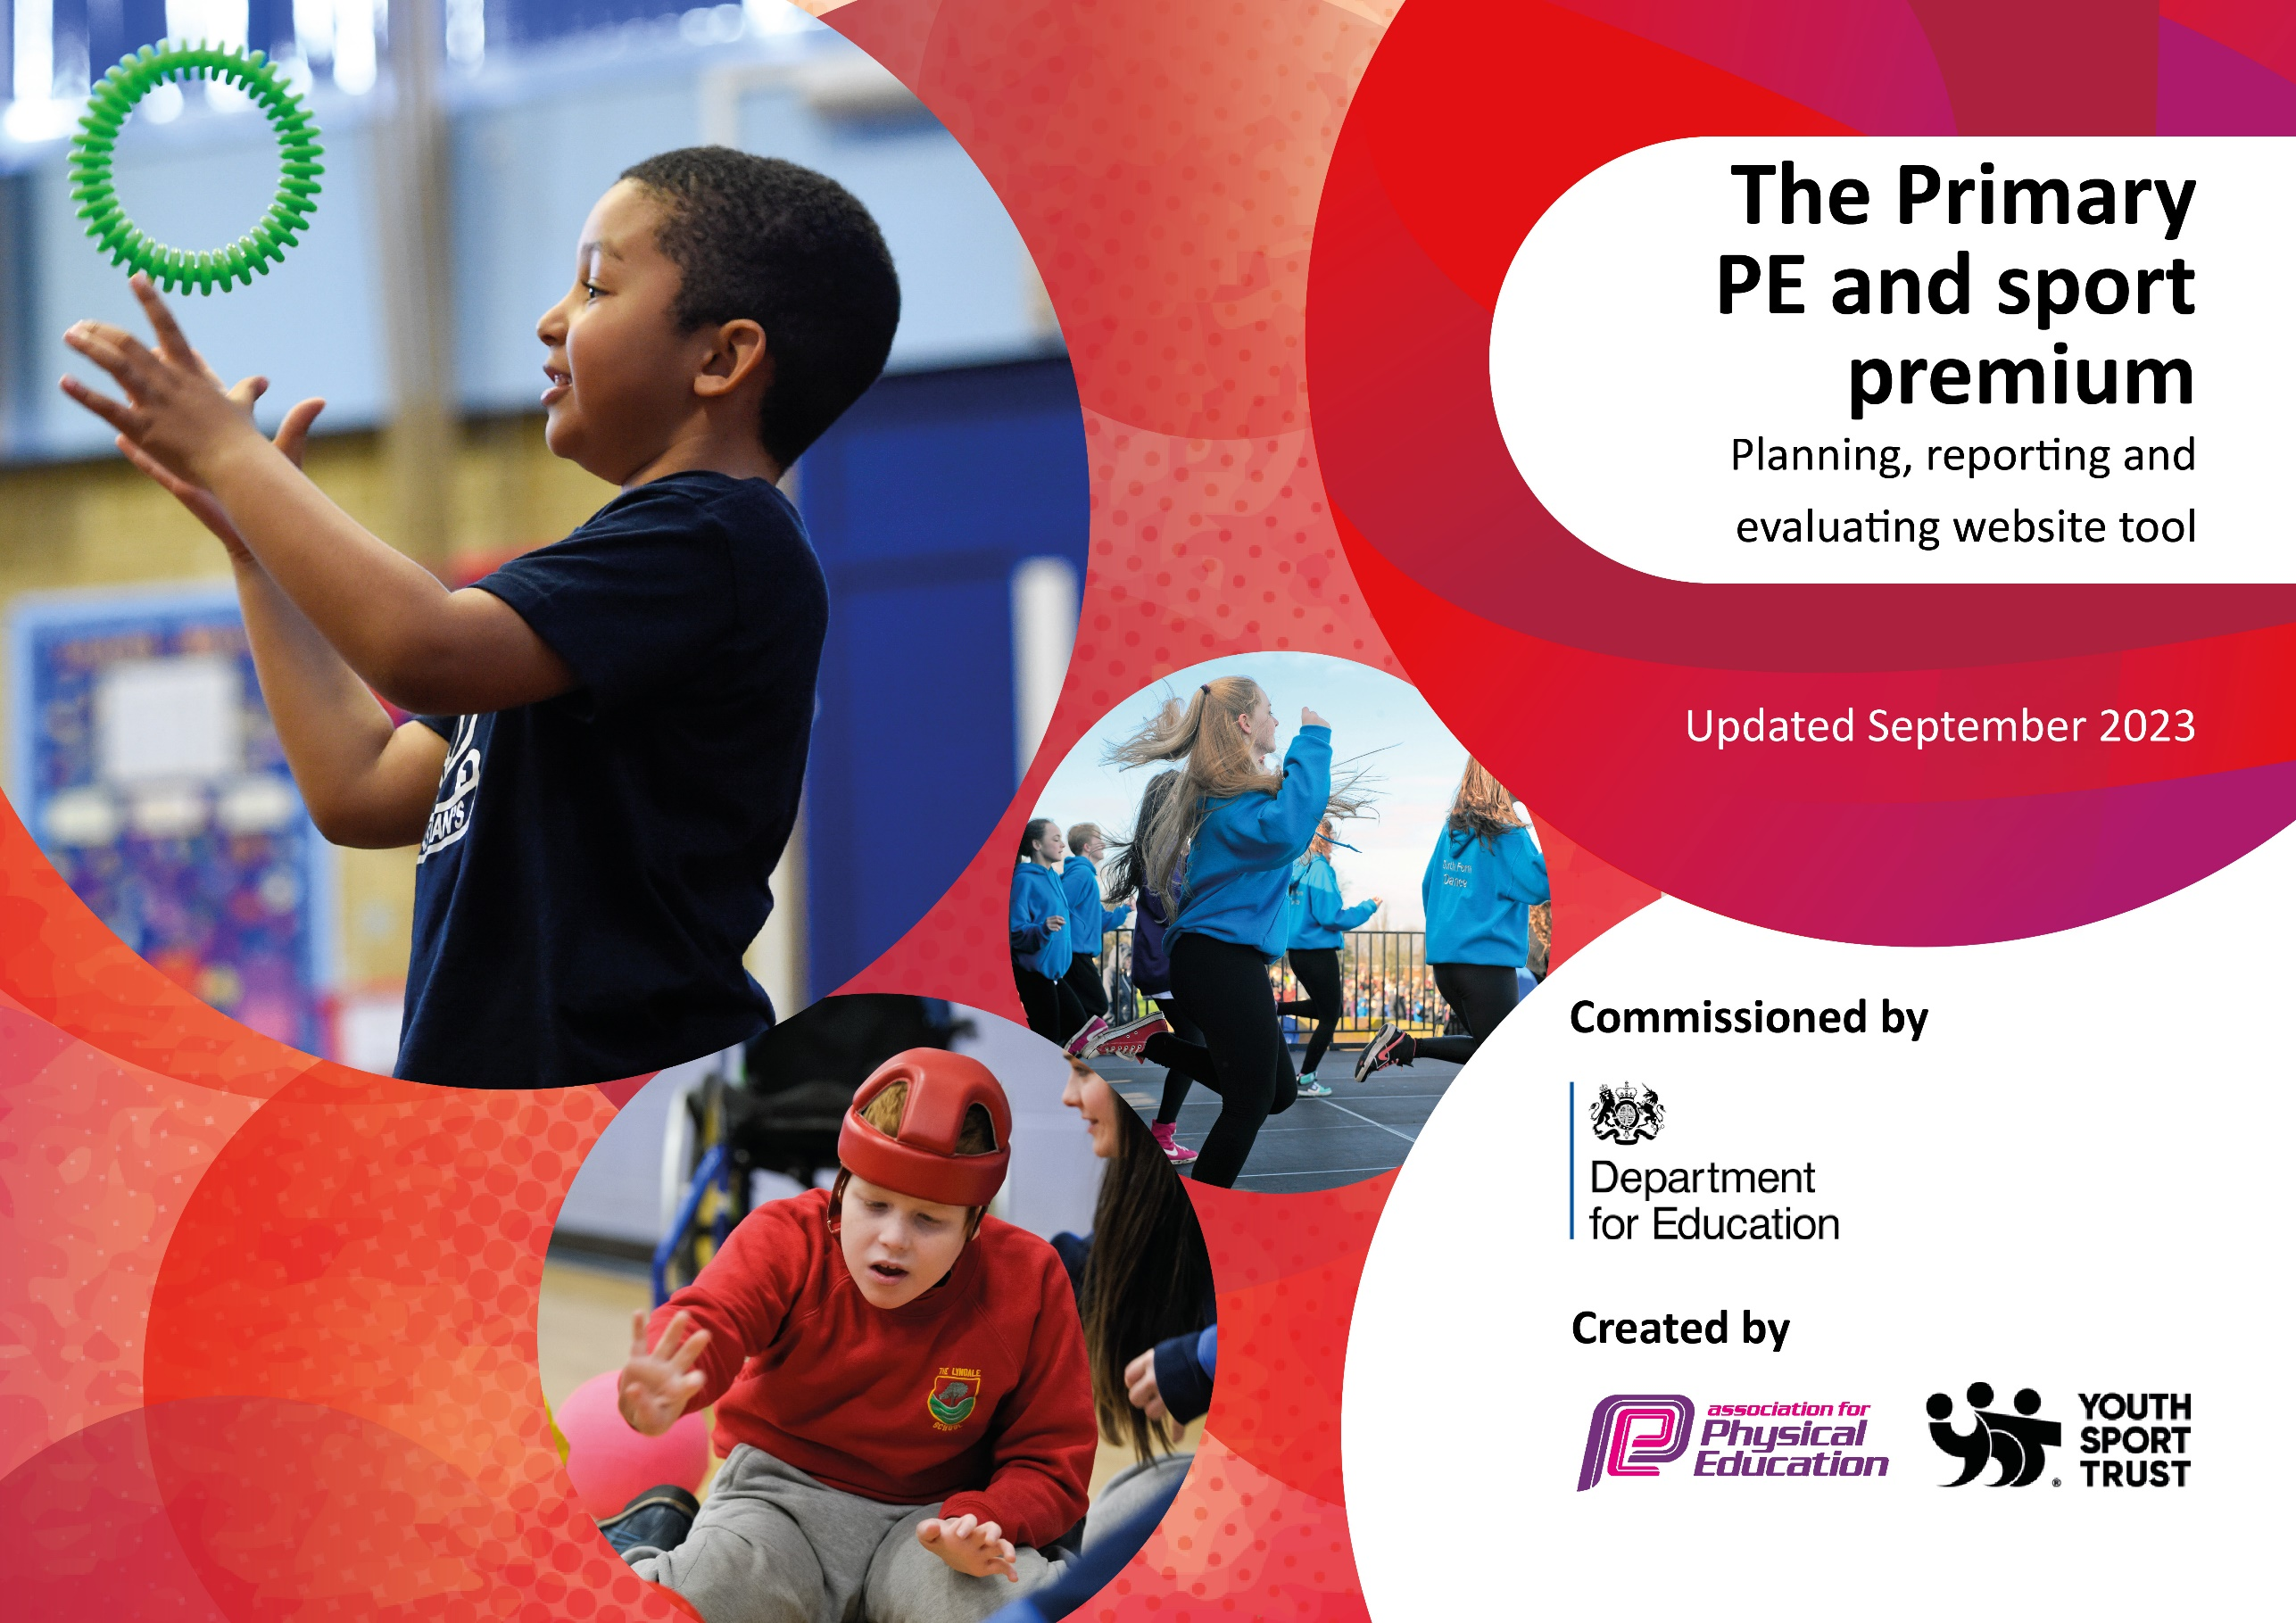

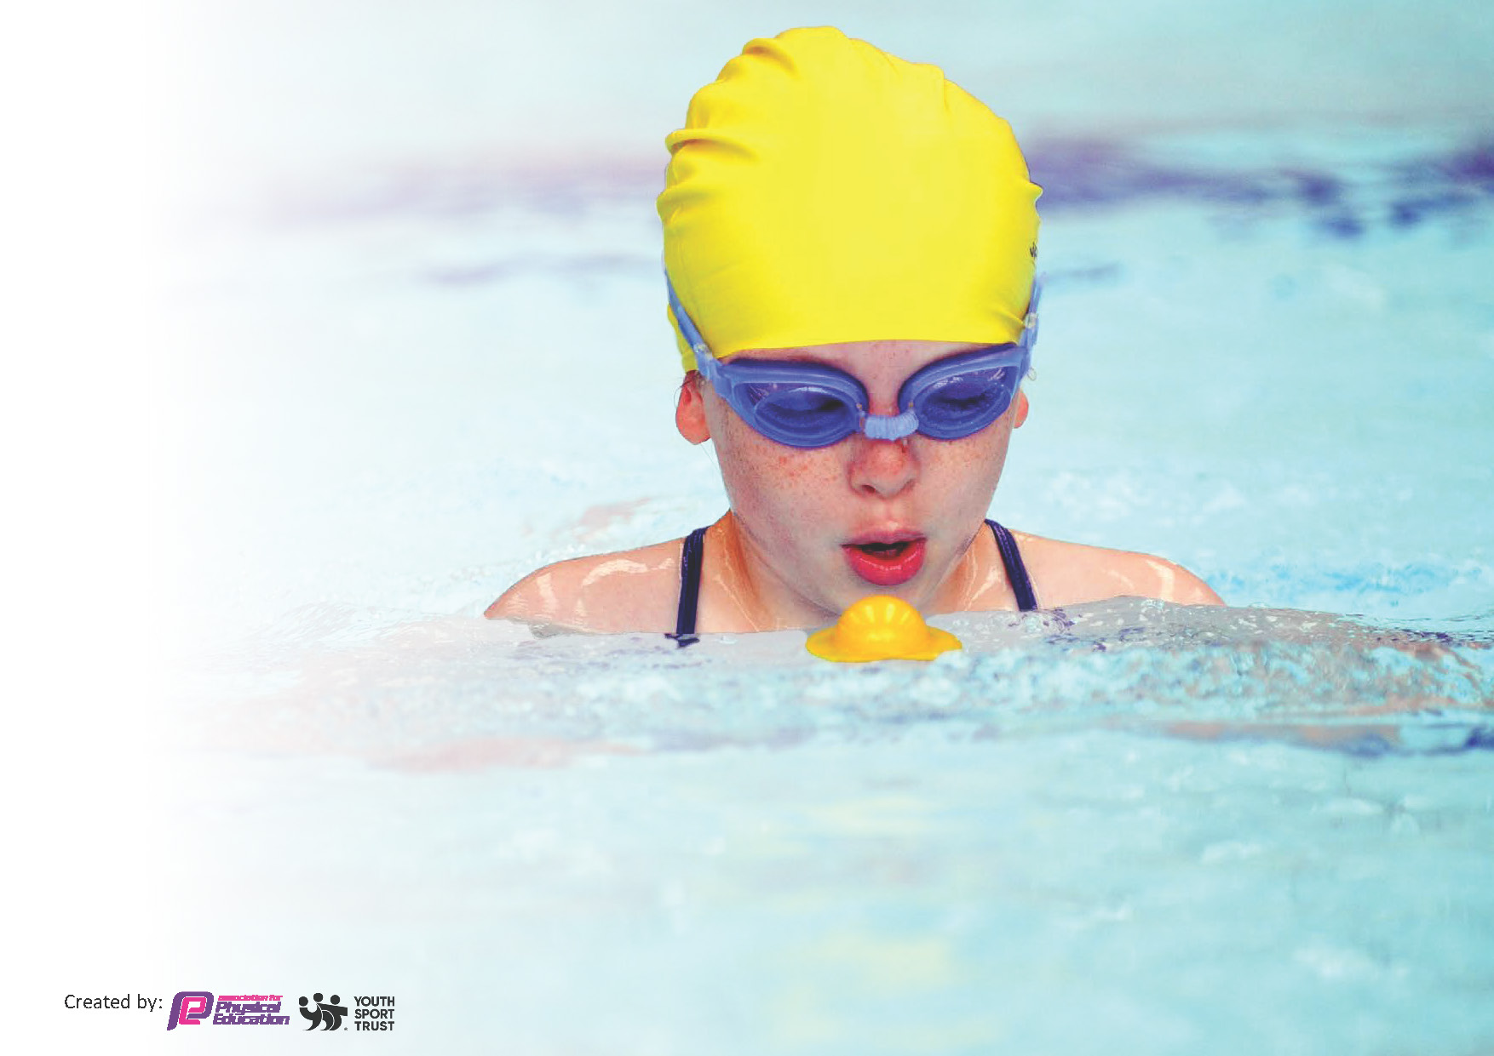
This template can be used for multiple purposes:
- It enables schools to effectively plan their use of the Primary PE and sport premium
- It helps schools to meet the requirements (as set out in guidance) to publish information on their Primary PE and sport premium
- It will be an effective document to support Ofsted inspections enabling schools to evidence progress in Physical Education (PE) and evidence swimming attainment, which forms part of the PE National Curriculum. We would recommend schools consider
the Intent, Implementation and Impact of any spend, as examined within the Education Inspection Framework.

It is important that your grant is used effectively and based on school need.

Schools must use the funding to make additional and sustainable
improvements to the quality of the PE, School Sport and Physical Activity (PESSPA)
they offer. This means that you should use the Primary PE and sport premium to:

- Build capacity and capability within the school to ensure that improvements made now will benefit pupils joining the school in future years
- Develop or add to the PESSPA activities that your school already offers.

The Primary PE and sport premium should not be used to fund capital spend projects; the school’s core budget should fund these. Further detail on capital expenditure can be found in the updated Primary PE and sport premium guidance.

The Primary PE and sport premium guidance, outlines 5 key priorities that funding should be used towards. It is not necessary that spending has to meet all the key priorities, you should select the priorities that you aim to use any funding towards.

Although completing this template is not a requirement for schools, schools are required to publish details of how they spend this funding. Schools must also outline what the impact this funding has had on pupils’ PE and sport participation and attainment and how any spending will be sustainable in the future. All funding must be spent by 31st July 2024.

The Department for Education has worked closely with the Association for Physical Education (afPE) and the Youth Sport Trust (YST) to develop this template and encourages schools to use it. This template is an effective way of meeting the reporting requirements of the Primary PE and sport premium.
Key priorities and Planning
This planning template will allow schools to accurately plan their spending.
Action – what are you planning to do | Who does this action impact? | Key indicator to meet | Impacts and how sustainability will be achieved? | Cost linked to the action
To ensure all children are participating in two hours a week of high quality PE by focusing on teacher training, curriculum evaluation:  - Quality of teaching and learning in Physical Education will be developed through bespoke staff CPD for all class teachers. Support for PE leader included.  - Create CPD timetable for co-delivery CPD delivered by our PE & School Sport Coordinator based on confidence surveys and observations.  - Access Subject Leadership workshops and teacher courses/support offered by Vale Royal School Sport Partnership.  - PE resources updated to enable high quality teaching to take place.  - Use the new Physical Literacy consensus statement to consider the purpose & intent of our curriculum and whether this is matched to implementation. | All class teachers as we build confidence and competence.  Every pupil as they access two hours of HQPE every week. | Key Indicator 1  By upskilling staff, we can ensure that all pupils’ will receive 2 hours of high quality physical education every week.  Key Indicator 1 and 3  100% of pupils will be developed in their physical, cognitive, social and emotional learning, therefore improving attainment data in PE and across the school.  Key Indicator 2  Pupils will be inspired through PE to be more active, therefore supporting the target for all pupils to be active on average 60 minutes a day, 7 days a week.  By using pupil voice more consistently across our school we can ensure that the curriculum better meets the needs of our learners, driving both engagement and progress. | Staff Confidence in July 2024 shows that 50% of teachers feel confident in teaching all areas of PE.  We predict that by July 2025, 70% of staff we feel confident in teaching all areas of the curriculum.  July 2024, Lesson observation feedback showed that 71% of lessons were ‘high quality’. By July 2025 we predict that all teachers will have been trained and that 86% of all lessons being delivered will be ‘high quality’.  Pupil voice data in July 2024 shows that 73% of pupils feel that PE is always fun. By July 2025, we predict that this will increase to 80%.  Sustainability: Staff will all be confident and competent. Continued CPD can come from sharing good practice in school and using Vale Royal School Sport Partnership courses and PE & School Sport Coordinator co-delivery support. | Booster swimming sessions for Y6 cohort delivered by experienced swimming coaches £1200  Sports coach delivering lunchtime intervention groups and after school clubs £2520  Vale Royal School Sports Partnership £3450

Action – what are you planning to do | Who does this action impact? | Key indicator to meet | Impacts and how sustainability will be achieved? | Cost linked to the action
To ensure that all pupils will be active on average 60 minutes a day, 7 days a week.  - Increase the number and range of activities and clubs on offer, reflecting pupil voice preferences of the less active groups in school (Pupil Led Games, dodgeball, games, dance, cheerleading.)  - Implementation of new extra-curricular timetable, ensuring balance for gender equality.  - Develop provision for physical activity at lunchtime by increasing the amount of playground resources to provide playground activity facilitated by lunchtime supervisors and year 6 playleaders.  - Review activity levels across the school day with teachers, considering feedback from pupil voice, and direct staff towards training and resources provided by VRSSP.  - Year 6 sports leaders and lunchtime supervisors trained in Playground Games.  - Equipment and resources to be bought for facilitation of activity with playleaders and independent active play. | Every pupil as they access further opportunities throughout the week to get active. | Key Indicator 2  Pupils will have more opportunities to be active, therefore supporting the target for all pupils to be active on average 60 minutes a day, 7 days a week.  Key Indicator 3  Improved behaviour at lunchtimes therefore supporting whole school improvement.  Key Indicator 4  Offer a broader and more equal experience of a range of sports and physical activities to all pupils. | In 2024 75% of Pupil premium who are SEN attended extra-curricular clubs at school.  Through the addition of new clubs we predict that by July 2025, 80% of children in this category will be attending extra-curricular sports clubs  By July 2025 we predict that 65% of children will be choosing to be physically active across a typical week at lunchtime on the back of new equipment and the playleaders active play activities.  Taking into account the lunchtime and extra-curricular additions, on top of activity outside of school:  In 2023/24, only 62% of all pupils were active for 60 minutes a day, 7 days a week on average. By July 2025, we are going to challenge 80% of pupils to achieve an average of 60 minutes a day 7 days a week.  Sustainability: Now they are trained, midday assistants to continue to provide the training to the next cohort of year 6 playleaders to allow for suitability. Continue to provide high quality extra-curricular clubs that are parent paid and therefore do not require any funding or teacher led and so free to attend. | New equipment for PE lessons and play leader breaktime sessions £2419.60

Action – what are you planning to do | Who does this action impact? | Key indicator to meet | Impacts and how sustainability will be achieved? | Cost linked to the action
Raise the profile of PE and sport across the school, to support whole school improvement by:  - Celebrate and assess the whole child through Physical Education ensuring strong personal development.  - Continue celebrations by introducing PE and School sport to Celebration assembly every term/half-term to ensure the whole school is aware of the importance of PE and Sport and to encourage all pupils to aspire to being involved.  - Promote physical activity outside of school and celebrate.  - Challenge attendance through the addition of new parent club. The parent club will focus on encouraging parents to value school, as well as PA. 9am club to ensure pupils are in and parents can then access free fitness classes. | All staff members including lunchtime staff.  Every pupil. | Key Indicator 1 and 3  By celebrating Physical Education, Physical Activity and School Sport, we are encouraging more pupils to enjoy movement and physical activity.  Key Indicator 3  By improving attendance, we are targeting a whole school priority.  Key Indicator 2  Pupils will be inspired to be more active, therefore supporting the target for all pupils to be active on average 60 minutes a day, 7 days a week. | See PE attainment data (whole child) in Key Indicator 1.  We predict that by July 2025, 75% of pupils will have been celebrated in our assemblies. This will be a celebration of the whole child – physical, cognitive, social or emotional learning.  The notice boards/newsletter are full of information about matches/clubs/results and pupils are keen to get involved.  By raising the profile of PE, Physical Activity and School sport, by July 2025 we are going to challenge 75% of all pupils to achieve an average of 60 minutes a day 7 days a week. See data above in KI2.  Sustainability: Continuing to report and celebrate pupil success in assembly has no long term cost and is part of the whole school drive to ensure PE and School Sport are central to the lives of all pupils.  On the PE notice board we will display sporting achievements/hobbies that are relevant to staff in school to ensure children can see that sport is not just becoming famous or being a world champion. By doing this hopefully we can highlight that taking part in sport can be part of everyone’s everyday life and not something out of reach.

Action – what are you planning to do | Who does this action impact? | Key indicator to meet | Impacts and how sustainability will be achieved? | Cost linked to the action
Offer a broader and more equal experience of a range of sports and physical activities to all pupils by:  - Continuing to offer a wider range of activities both within and outside the curriculum in order to get more pupils involved: Extra-curricular – Dodgeball, Dance, Netball, Football, Multi Skills, Cheerleading, Volleyball.  - Focus particularly on those pupils identified as semi-active/not active in our pupil voice survey, who do not take up additional extra-curricular opportunities.  - Last year it was identified that football was the most sought-after extracurricular club, however, the children identified a want for cycling to be offered as an opportunity. | Every pupil as they access further opportunities throughout the week to get active. | Key Indicator 4  Offer a broader and more equal experience of a range of sports and physical activities to all pupils.  Key Indicator 2  Pupils will be inspired to be more active, therefore supporting the target for all pupils to be active on average 60 minutes a day, 7 days a week. | A new sports coach was hired this year to provide a Cheerleading and Dance club after school to provide an offer of sports that are not team based or competitive. 70% of the girls across KS1 and KS2 have attending Cheerleading and Dance clubs.  We have used sports premium this year to invest in a set of bikes for the children to use as part of their OPAL play. We have also had the Bikeability team in to work with Years 5 and 6 to introduce the children to riding safely on the roads.  Having access to these bikes means that 8 of our Pupil premium children who don’t have access to a bike at home are now much more confident riders. Improving their fundamental movement skills and meaning that they’ve increased their daily level of physical activity significantly.  We have used the Koboca survey to gain pupil voice. This has provided us with an insight into how popular and engaging the provision we have provided has been with the children.  Sustainability: Continue to use pupil voice and liaise with families to ascertain the clubs and activities that are pupils want to be attending. Continue to provide high quality extra-curricular clubs that are run by high quality coaches and are clubs that the children choose via the Koboca survey. | £300 bikes  £1320 Dance and Cheerleading Coach

Action – what are you planning to do | Who does this action impact? | Key indicator to meet | Impacts and how sustainability will be achieved? | Cost linked to the action
Increase the number of pupils participating in an increased range of competitive opportunities.  - Intra: Continue to drive effective house system for engaging in competition in lesson time. This means there can be an in-class competition for all classes at the end of the unit. (Focus on personal development (key life skills) through competition, bespoke to pupils needs.)  - Inter: Engage with an increased number of Inter competitions for both KS1 and KS2.  - Team fixtures/friendly competitions and School Games competitions.  - Review participation to ensure event entries match our pupils motivation, competence and confidence (via Celebrate, Aspire & Inspire categories) and provide equal opportunities for boys and girls. | All pupils have access to competition. | Key Indicator 5  Increase participation in competitive sport.  Key Indicator 2  Pupils will be inspired through to be more active, therefore supporting the target for all pupils to be active on average 60 minutes a day, 7 days a week. | 2023/24, 100% of children in KS2 competed in 1 Intra level 1 competitions. (Sports day and house cricket).  100% of KS1 competed in 1 Intra level 1 competition, (Sports day).  (Percentage is based on the children present on the day of Sports day).  By July 2025 there will be an increase in intra school competitions through more  opportunities in lesson time by celebrating  learning at the end of a unit.  We predict that  90% of KS1 will access at least 3 competitions and  90% of KS2 will access at least 6 competitions.  Competition intent based on success via demonstration of specific life skills and values.  2023/24 15% of KS1 took part in an Inter competition and 33% of KS2 participated in 13 Inter competitions (football, netball, boccia, basketball, hockey, athletics, dance, dodgeball).  By July 2025, we predict that 30% of KS1 and 45% of KS2 will take part in an Inter school competition.  Sustainability: Competition will be imbedded as a normal element of learning through continued access to house competitions in class/lesson time at the end of units. Complete PE supports this set up and guides teachers.
Key achievements 2023-2024
This template will be completed at the end of the academic year and will showcase the key achievements schools have made with their Primary PE and sport premium spending.

Activity/Action | Impact | Comments
This year we have invested in a set of bikes for the children to use on our trail track during OPAL play.  Children have thoroughly enjoyed the new cheerleading and dance club started by our new sports coach.  Provide swimming booster sessions for children who have struggled to pass the national curriculum objectives at the end of KS2 | This has resulted in more children being active at lunchtimes and we have seen a decrease in negative behaviour arising during unstructured times.  Some of our more vulnerable children have formed a tight bond to them and are excited each week to attend the club. We have seen an increase in the number of girls attending after school clubs since these sessions have been introduced.  Children who attended these booster groups had an increase in confidence and expressed how happy they were to be swimming. Most of these children either passed their objectives or managed to achieve their silver award. | Next year we would like to invest in more bikes of a larger size, so that these can be accessed by the older children with the potential of a new cycling club starting.  Next year we are hoping this coach will continue with cheerleading and dance, but also introduce a gymnastics club.  Next year we are aiming to add an extra week of swimming booster sessions to ensure the children who need the extra support are able to access whatever they need.

Swimming Data
Meeting National Curriculum requirements for swimming and water safety.
Priority should always be given to ensuring that pupils can perform safe self-rescue even if they do not fully meet the first two requirements of the National Curriculum programme of study

Question | Stats: | Further context  Relative to local challenges
What percentage of your current Year 6 cohort can swim competently, confidently and proficiently over a distance of at least 25 metres? | 78% | For the past couple of years, we have had to rent an onsite pool for swimming lessons due to our local pool closing. Therefore, we have had to timetable the swimming lessons for KS2 into the 2 weeks we have managed to book the pool onsite for. This has impacted on each year group having consistent lessons.
What percentage of your current Year 6 cohort can use a range of strokes effectively [for example, front crawl, backstroke, and breaststroke]? | 89% | A larger percentage of children can use the various of strokes, however, a small percentage are unable to sustain this over the 25m required to meet end of KS2 objectives.

What percentage of your current Year 6 cohort are able to perform safe self-rescue in different water-based situations? | 89% | We have 2 children with EHCP’s in our Year 6 cohort, due to their sensory sensitivities they have found swimming particularly challenging.  2 of the current cohort broke limbs in Year 5 and were therefore unable to access the swimming lessons prior to Year 6. They had access to the booster sessions.  2 students have transitioned into our Year 6 class in recent weeks and so have not accessed swimming with us before.
If your schools swimming data is below national expectation, you can choose to use the Primary PE and sport premium to provide additional top-up sessions for those pupils that did not meet National Curriculum  requirements after the completion of core lessons. Have you done this? | Yes/No
Have you provided CPD to improve the knowledge and confidence of staff to be able to teach swimming and water safety? | Yes/No | Our swimming staff are supplied by the sports coaching group and so receive all their relevant training through them.

Signed off by:

Head Teacher: | L Guy and C Harrison
Subject Leader or the individual responsible for the Primary PE and sport premium: | E Hadfield, PE Lead
Governor: | (Name and Role)
Date: | 19/07/2024

