Leftwich Community Primary School.

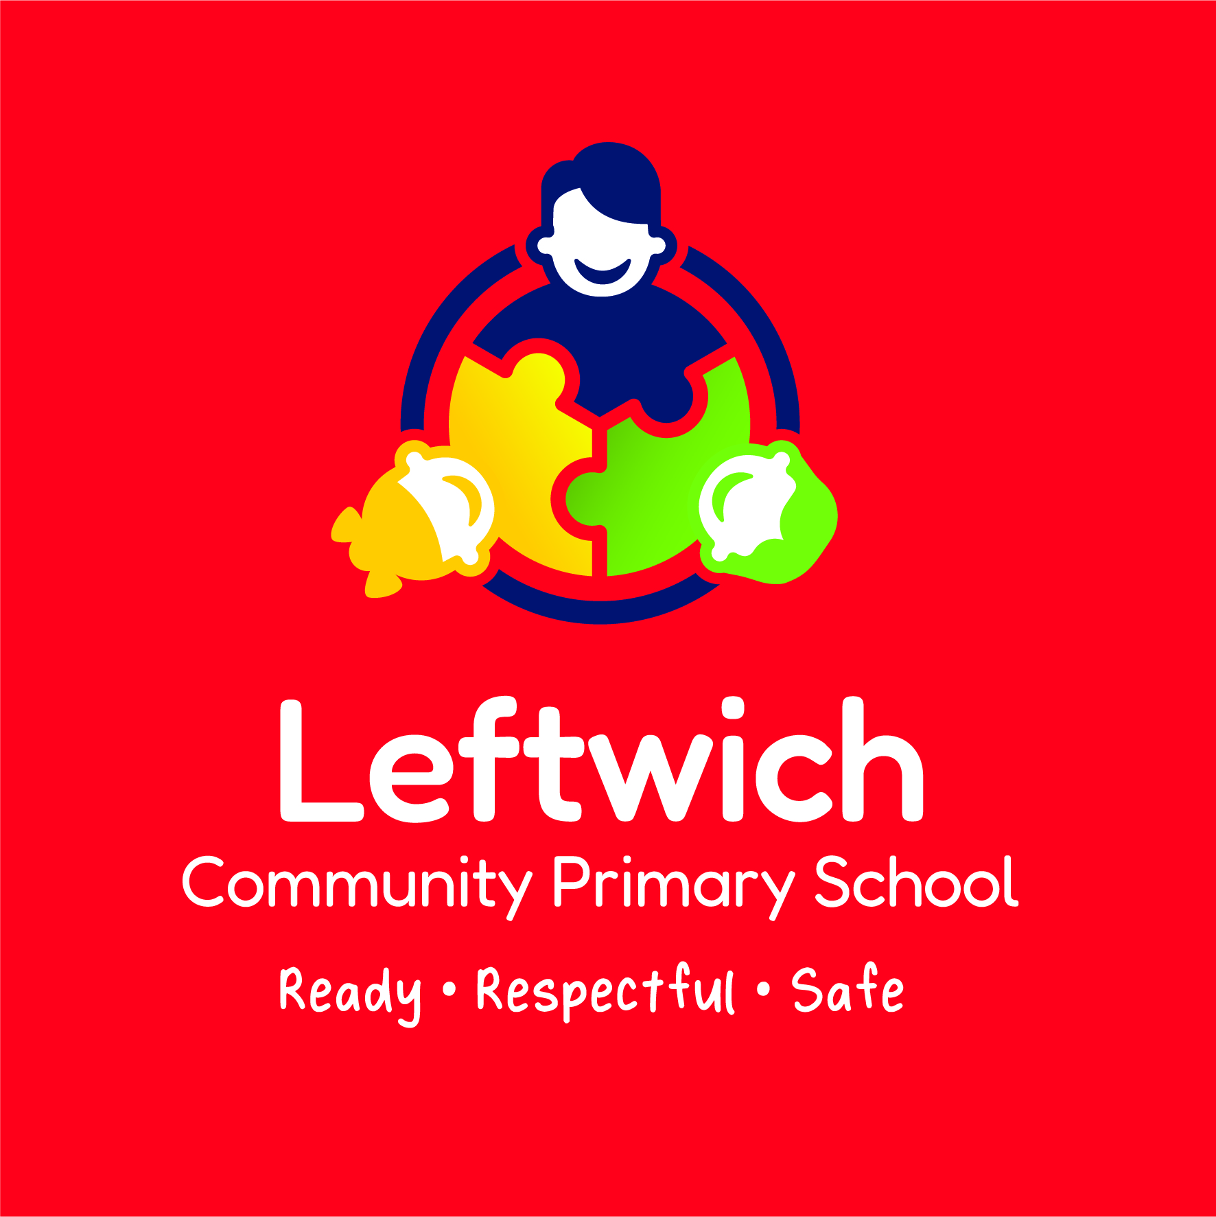

A guide for parents as your child
starts school.

The School Day

8.30- 8.45 a.m. Doors Open
Doors will be open from 8.30 a.m. when children can come into school. All children should be in school from 8.45 a.m. Parents are welcome to come in and play, read with their children for 10 minutes for the first term.

11.10 – 11.25 a.m. Playtime

10.55 – 11.10 a.m. Snack
Please provide a bottle of plain water for this time as well as for access throughout the day. Fruit and milk are provided by school but fruit of your child’s choice may be brought from home. (Milk is provided free until your child is 5)
12.00 – 1.00 p.m. Lunchtime
The cost of a school lunch is now free for infant children. Alternatively, your child may bring a packed lunch from home.

3.15 p.m. End of School
A member of the Reception staff will open the gate and ensure that all children are delivered safely to parents.

For school your child will need:
Our school uniform | Red school sweatshirt/cardigan, white or red polo shirt, black/grey trousers or skirt, sensible black school shoes.
A PE Kit | T-shirt (house colour), navy or black shorts, a soft drawstring PE bag. Pumps are not needed until the Summer Term.
A Book bag | Can be bought from school.
A Water Bottle | Clear if possible

Early Years Foundation Stage

Children in the Reception class are working in the final year of the Early Years Foundation Stage (EYFS). This stage is a continuation of the work from your child’s previous setting and the work that you are already doing at home.

The Early Years Foundation Stage Curriculum

The curriculum is divided into seven areas of learning and development. These areas contain Early Learning Goals, which are the knowledge, skills and understanding that your child should reach or be working towards by the end of the Reception year.

The seven areas covered by the goals are split into Prime and Specific areas of learning.

Prime areas are fundamental, work together and support development in all other areas of learning. The prime areas are:

- Personal, Social and Emotional Development
- Communication and Language
- Physical Development

Specific areas include essential skills and knowledge for children to participate successfully in society.

- Literacy
- Mathematics
- Understanding of the World
- Expressive Arts and Design

Your child will cover all these areas through planned and purposeful play both indoors and outdoors. There will be a balance of adult led activities and their own child initiated activities.

The following pages give ideas of how you can support your child within each of the EYFS areas of learning:

Personal, Social and Emotional Development

The idea here is to provide your child with experiences and support to help him/her develop the way the make relationships, their self-confidence and self-awareness and managing their feelings and behaviour. Some of these ideas will be things that you will already be doing everyday with your child:
Try out new things such as handprints or baking together.
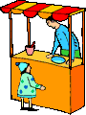
Speak out to other adults. E.g. ask for his/her own ice-cream.


Be encouraged to concentrate on and finish an activity such as finishing a book, playing a game.


Look after things such as his/her pets and toys.

Dress and Fasten
undress. their shoes.

Take off and
hang up their
coat.

Sort out problems.

Communication and Language

The Foundation Stage encourages the support and extension of your child’s learning and competence in listening and attention, understanding language and being able to speak it. Below are ideas which will support this:

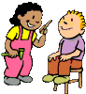
Give your child opportunities to role play and play with small world toys. Encourage different voices and join in with their imaginary games.
Make up stories together about things you’ve done. Your child could make his/her own little books.

Read picture books and story books together. Visit the local library.

Sing songs, read poems and nursery rhymes. Make jigsaws and play games e.g. I spy and matching games.


Introduce new words for your child to use, use them a few times and your child will naturally pick them up.


Encourage your child to speak out clearly and with confidence when talking. E.g. he/she could ask for his/her drink in a café.

Physical Development

Physical development encourages your child to be active and improve his/her skills of coordination, control, manipulation and movement. Your child should also understand the importance of healthy food choices. Below are some ideas to support this area:

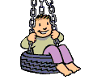
Take your child to the local park to play.


Take your child swimming.



Encourage your child to play active games outdoors. Talk about the changes that happen to his/her body when active, such as getting hot.


Talk about ways to keep your child safe.


Talk about ways that we can keep ourselves healthy,
including healthy food choices and keeping clean.



Use small equipment to develop fine motor skills.

Use the toilet Wash their
and flush it. hands.

Use a handkerchief.

Literacy

The Foundation Stage encourages the support and extension of your child’s learning and competence in being able to read and write on his/her own. Below are ideas which will support this:

Write letters or shopping lists together. Any kind of mark making will be ‘writing’ to your child. Get your child to ‘read’ back what he/she has written. As your child moves through the ‘letters and sound programme’ at school, you will find he/she will add sounds and words into his/her writing.

Give opportunities to draw and write with different kinds of pens, pencils, crayons and different kinds of paper.


Read signs in the general environment

Share a bedtime story together


Find opportunities to mark make – this might be a stick in the mud out in the garden or drawing in the sand on the beech

Find opportunities for children to recognise their name
Sam Ella Joe Jacob Rose William

Mathematics

In this area your child will be expected to develop his/her understanding of numbers and shape, space and measure. Opportunities to support your child in this area arise all the time. Below are some ideas:

Say numbers in counting or singing number rhymes.


Talk about numbers that are all around you.

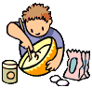
Talk about numbers in everyday activities such as in baking, setting the table etc.

Talk about things that are bigger, smaller, heavier or lighter to compare quantities.


Talk about solid and flat shapes that you can see around you.


Count in everyday activities such as candles on a cake, going up the stairs, apples in a bag.


Use everyday words to describe position, such as on top, go forwards, underneath, to the side etc.

Talk generally about time; tell the time, days of the week, order of the day, things done in the morning, afternoon, evening, months of the year and seasons.

Understanding the World

Understanding the world helps your child make sense of the world around them by looking at people and communities, the world and the technology that exists in it. There are opportunities to support your child with this area in everything you do.

Give your children opportunities to investigate things around them.

Ask questions about how things work.


Identify things in the natural world all around and talk about things that he/she like and don’t like.

Use everyday technology around them. Cameras, computers, TV, handheld machines etc will all support this.

Your child should know about his/her own culture and the culture of others.

Select his/her own tools to assemble things and join materials such as cutting paper to wrap a present.


Investigate things that are similar, different, patterns and changes.
For example an ice cream will melt when it is warm.

If he/she blows slowly, the bubbles will be bigger.


Understand that people have differences in their lives to our own. E.g. Some people go to church, some do not, and some might go to Mosque
Expressive Arts and Design

In this area, children will be expected to explore using various media and materials and be imaginative. You can support your child’s creativity in his/her general exploration and play. This could be in art, movement, music, dance and imaginative and role play activities. Below are some activities which would support this:

Sing songs together and dance to music.


Play musical instruments and talk about how they are making sounds. Make simple musical instruments together such as elastic bands over a box, rice in a jar.

Dress up and play imaginative role play games. Encourage your child to make up games with small world toys.

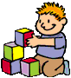
Use imagination when building models with equipment such as wooden bricks, duplo, k’nex etc. Make models with simple boxes. For example a rocket to go to the moon, a bed for Barbie, Action Man.


Paint and explore colour when drawing pictures of things your child can see or from his/her imagination. Have various crayons and paint to do this
Play with play dough, make models with it. Pretend to cook.

Paint with water on a sunny day, handprint, use sticks to draw outdoors

